 | Oxford Diocesan Schools Trust  St Mary’s Convent  Denchworth Road, Wantage  Oxford, OX12 9AU  odst.governance@oxford.anglican.org  www.odst.org.uk

Food Hygiene Policy
New Town Primary School

Adopted by school: | New Town Primary School
Date: | July 2025
Next review date: | July 2028

Training

All staff who are leading and taking part in food preparation at school should ensure they have appropriate training in Food Hygiene, which is regularly renewed.

Teaching and learning

All children will have the opportunity to participate in food preparation and tasting at school, in a wide variety of subjects. This aspect of learning contains important skills for children to acquire, and will equip them with life-long knowledge on their journey to independence. In the same way children learn about nutrition and the design of food products, they should also learn basic food hygiene in order to keep themselves safe and well. The basic principles outlined below should be taught as an integral part of food preparation teaching and learning, at an age appropriate level.

Good food safety and hygiene practices

All staff and pupils should:

Ensure that ingredients and finished dishes are stored correctly:
- Staff should store high risk ingredients (such as meat, fish and dairy products plus opened bottles, jars or tubes) in a fridge before the start of the school day;
- all foods placed in the fridge must be wrapped and clearly labelled. Bags that might have been on the floor should not be put in the fridge as this can cause cross-contamination;
  - food containing allergenic ingredients should be stored separately;
  - hot food should be cooled quickly and stored below 5°C within 1-2 hours;
  - finished dishes should be stored appropriately in the food room until the end of the day;
  - pupils should be advised of reheating methods, times, temperatures and allergens in dishes made (e.g. labels placed on containers) where appropriate;
  - dishes not collected after 48 hours, or 24 hours for rice dishes, should be placed in food waste bins.

Adopt a regular routine for getting ready to cook:
- remove jumpers and roll up sleeves where appropriate when cooking
- remove nail varnish, jewellery and watches;
- tie up long hair, ensuring it is not hanging down;
- secure long head scarves or coverings;
- thoroughly wash and dry hands with water and soap
- put on a clean apron - this is to prevent any contaminants transferring from clothes into food and also keeps clothes clean;

Demonstrate excellent practical skills and food hygiene and safety practices;
- use and store electrical equipment safely, e.g. food processors or blenders;
- use clean, tidy and effective procedures for practical activities;
- use equipment correctly in order to prevent cross-contamination, e.g. using different chopping boards for different food groups;
- avoid washing raw meat to prevent cross-contamination;
- if applicable - use digital temperature probes to check the core temperature of food is at least 75°c (or 70°c for 2 minutes).

Follow hygienic and safe procedures for tasting, testing and setting up the session:
- check allergenic ingredients in food used for tasting or investigations and cross match this against pupils’ known allergens and dietary requirements or restrictions
- ensure that tasting is completed hygienically, e.g. no ‘double dipping’ or licking fingers.

Good food safety and hygiene practices guide for pupils:

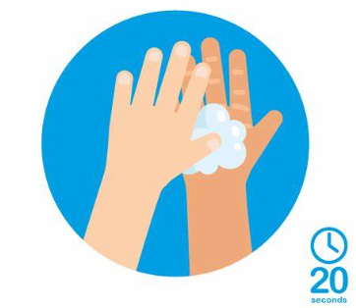  The importance of washing hands and how to do it properly | Tying hair up, removing jumpers and jewellery, putting on aprons | Storing food correctly in a fridge |   Washing and drying up thoroughly. Putting equipment away correctly
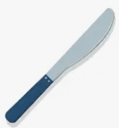  Safe use of kitchen knives | Safe use of grater | Safe use of peeler | Safe use of the kettle
Safe use of the grill | Safe use of the oven and hob | Using oven gloves to put food into the oven and take it out once cooked | Safe use of the blender/processor
Safe use of electric whisks |   Safe handling of raw meat and poultry | Safe cooking of raw meat and poultry

